Extra notes for Az-104

**Questions**:

* File Sync Steps:
  + 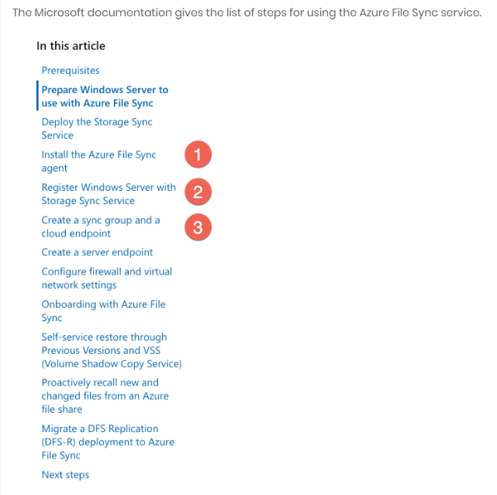
* MS Export/Import job:
  + 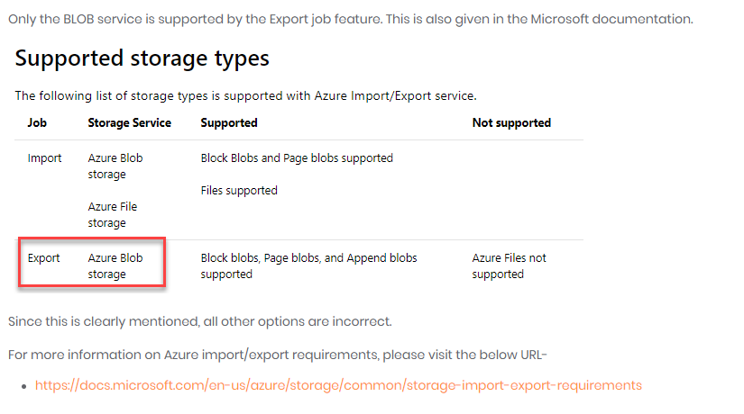
* Basic/Standard Load Balancers require the VMs/VMSSs to be in the same VNET (or single VNET)
  + 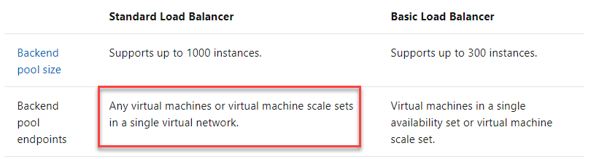
* Azure Administrators have a diff interaction with Password Reset Policy (two-gate password reset policy)
  + 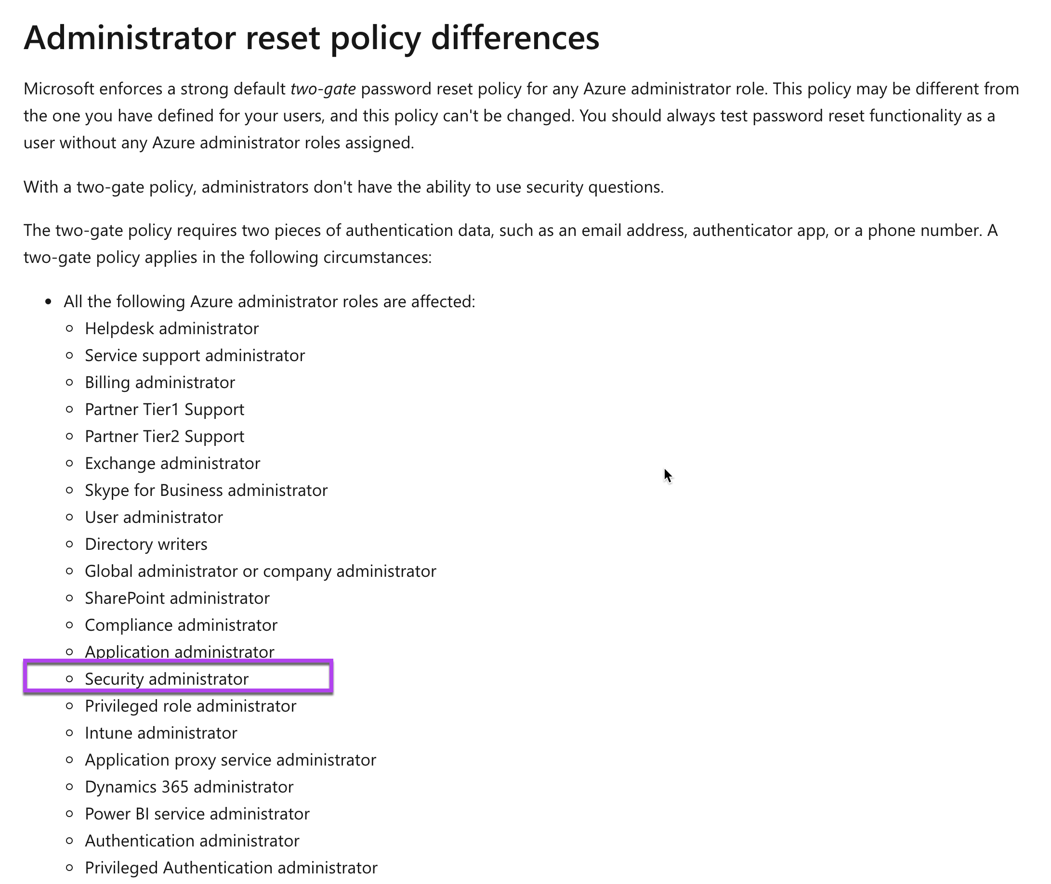
* Azure Scale Sets are a “free service” so they don’t have an SLA. Only if you consider the Scale Set w/ 2+ Fault Domains, do the availability of the underlying VMs SLA apply
  + 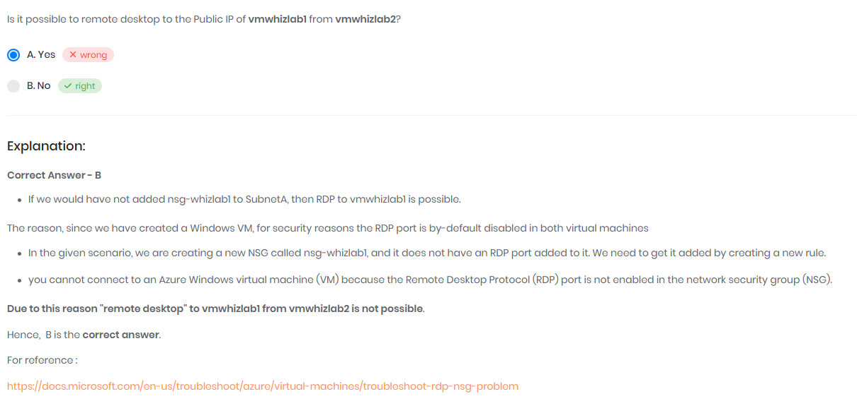
* To Protect Web servers against SQL injections, use App Gateway with the WAF features
  + WAF = Web app firewall feature
  + 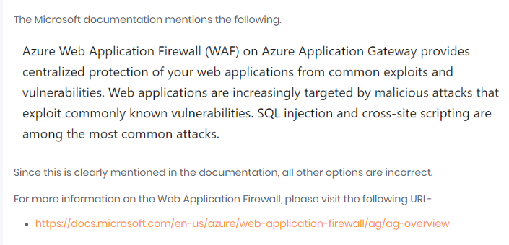
* Guarentee SLA of at least 99.5% for Availability of VM
  + Use Managed Disks and Availability Sets
  + 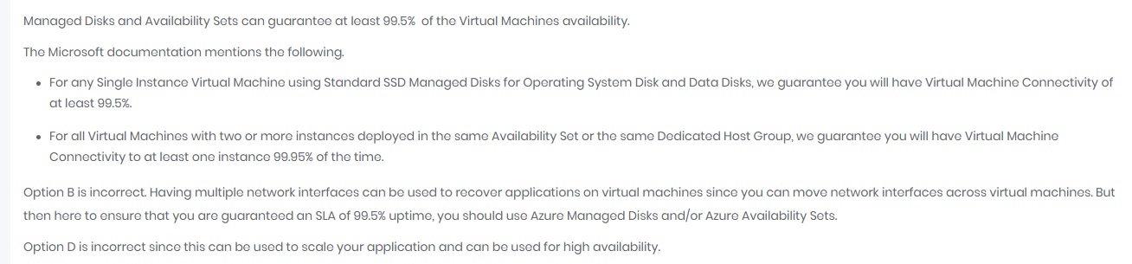
* RDP to public IP of VM1 from VM2:
  + 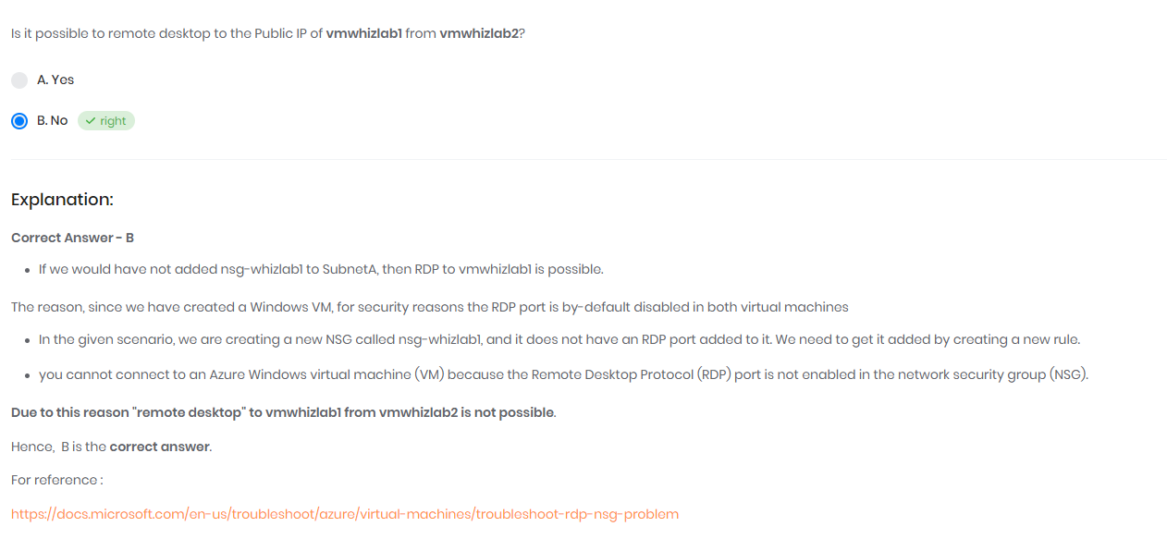
  + NSG by default will disable RDP port (3389)
* 